Product / Process Change Notice

Parts Affected:

Chip process CP206, N-Channel Field Effect Transistors, wafers, and bare die.

Extent of Change:
The CP206 wafer process has been discontinued and replaced with the CP216 wafer process. See figures 1 and 2 for details.

Reason for Change:
This process was transferred to an alternate wafer foundry which provides improved and consistent yields.
Revision 1 September 26, 2019: Issued to include additional devices not on the initial PCN release. Newly added devices are shown in the “Part Numbers Affected” section on page 3 marked with *.

Effect of Change:
The wafer process meets all electrical specifications of the individual devices listed on the following page.

Qualification:

Test | Condition | Failure rate
Resistance to Solder Shock | T =260°C ±5°C  Dwell time = 10 sec.  JESD22-B106 | 0/77
High Temperature Storage Life/ bake test. | 150°C (-0/+10)°C, 1000 hours.  JESD22-A103 | 0/77
Temperature Cycling | T= -65°C to +150°C  1000 cycles. Dwell time = 15 min.  JESD22-A104 | 0/77
High Temperature Reverse Bias (HTRB) | T=125°C, t=1000 hours, V_{R}=V_{Z}  JESD22-A108 | 0/77
Highly Accelerated Temperature and Humidity Stress Test (HAST) | T = 130°C, RH = 85%, P = 33.3 psia, and t = 96 hours.  Bias conditions per device specification sheet.  JESD22-A110 | 0/77
Accelerated Moisture Resistance Unbiased Autoclave | Temperature = 121°C ± 2°C; relative humidity = 100%; vapor pressure = 29.7 psia (15psig). t=96 hours  JESD22-A102 | 0/77

Effective Date of Change:

April 16, 2018 - Existing inventory will be shipped until depleted.

Sample Availability:

Please contact Salesperson or Manufacturer’s Representative.

Figure 1: CP206 Chip Geometry (Discontinued) Figure 2: CP216 Chip Geometry

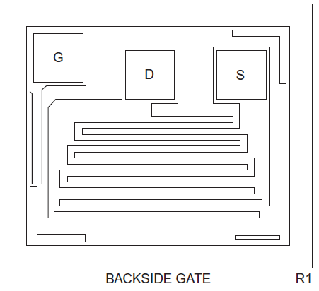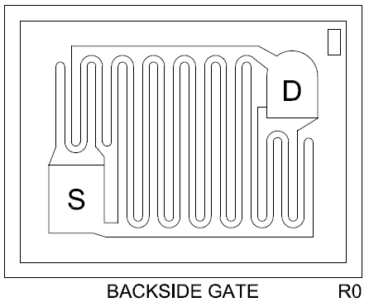
Wafer Diameter: 5 inch
Die Size: 21 x 18 mils
Die Thickness: 8.0 mils
Bond Pad Size (Drain): 3.0 x 3.0 mils
Bond Pad Size (Source): 3.0 x 3.0 mils
Bond Pad Size (Gate): 3.0 x 3.0 mils
Topside Metal: Al (30,000Å)
Backside Metal: Au (6,000Å)
Wafer Diameter: 4 inch
Die Size: 21 x 16 mils
Die Thickness: 7.9 mils
Bond Pad Size (Drain): 3.3 x 4.5 mils
Bond Pad Size (Source): 3.3 x 4.5 mils
Topside Metal: Al (10,000Å)
Backside Metal: Au (3,250Å)

Part Numbers Affected:

2N4391 | CP206-2N4391-CT
2N4392 | CP206-2N4391-WN
2N4393 | CP206-2N4392-CM
2N4092 | CP206-2N4392-CT
2N4861 | CP206-2N4392-WN
2N4861A | CP206-2N4393-CT
CMPF4391 | CP206-2N4393-WN
CMPF4392 | CP206-2N4856-CM*
CMPF4393 | CP206-2N4856-CT*
PN4091* | CP206-2N4856-WN*
PN4092* | 2N4091*
PN4093* | 2N4856*
PN4391* | 2N4856A*
PN4392* | 2N4857*
PN4393* | 2N4857A*
CEN1280* | 2N4859*
 | 2N4859A*

*Revision 1 September 26, 2019 newly added devices

As per JEDEC standard JESD46, Customer Notification of Product/Process Changes by Solid-State Suppliers, a lack of acknowledgement of a PCN within thirty (30) days constitutes acceptance of the change.

The undersigned acknowledges and accepts Central Semiconductor’s Product/Process Change Notification (PCN).

Company Name:

Address:

Printed Name:

Title:

Signature:

Date:

