Product / Process Change Notice

Extent of Change:

Chip process CP305, NPN silicon transistor wafers and bare die.

Extent of Change:
The CP305 wafer process has been discontinued and replaced with the CP306V wafer process. See figures 1 and 2 for details.

Reason for Change:
New wafer process provides an improved and consistent yield.

Effect of Change:
The wafer process meets all electrical specifications of the individual devices listed on the following page.

Effective Date of Change:
December 1, 2017

Sample Availability:

Please contact Salesperson or Manufacturer’s Representative.

Qualification Tests:

Test | Condition | Failure rate
Resistance to Solder Shock | T =260⁰C ±5⁰C  Dwell time = 10 sec.  JESD22-B106 | 0/77
High Temperature Storage Life/ bake test. | 150°C (-0/+10)°C, 1000 hours.  JESD22-A103 | 0/77
Temperature Cycling | T= -65⁰C to +150⁰C  1000 cycles. Dwell time = 15 min.  JESD22-A104 | 0/77
High Temperature Reverse Bias (HTRB) | T=125⁰C, t=48 hours, 80% MAX rated VCB  JESD22-A108 | 0/77
Highly Accelerated Temperature and Humidity Stress Test (HAST) | T = 130°C, RH = 85%, P = 33.3 psia, and t = 96 hours.  Bias conditions per device specification sheet.  JESD22-A110 | 0/77
Accelerated Moisture Resistance Unbiased Autoclave | Temperature = 121⁰C ± 2⁰C; relative humidity = 100%; vapor pressure = 205kPa, 29.7 psia. t=48 hours  JESD22-A102 | 0/77

Figures:

Figure 1: CP305 Chip Geometry (Discontinued) Figure 2: CP306V Chip Geometry

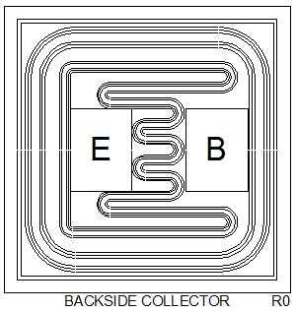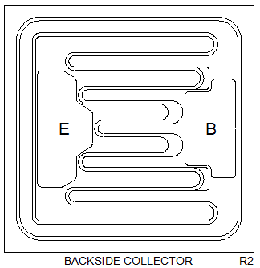

Wafer Diameter: 5 inch
Die Size: 27.56 x 27.56 mils
Die Thickness: 7.1 mils
Bond Pad Size (Emitter): 5.9 x 7.9 mils
Bond Pad Size (Base): 5.9 x 7.9 mils
Topside Metal: Al-Si (30,000Å)
Backside Metal: Au (9,000Å)

Wafer Diameter: 4 inch
Die Size: 31 x 31 mils
Die Thickness: 9.0 mils
Bond Pad Size (Emitter): 6.5 x 13.8 mils
Bond Pad Size (Base): 5.9 x 11.8 mils
Topside Metal: Al (30,000Å)
Backside Metal: Au (18,000Å)

Part Numbers Affected:

CP305-2N3019-CT
CP305-2N3019-CT20
CP305-2N3019-WR
CP305-2N3700-CT

As per JEDEC standard JESD46, Customer Notification of Product/Process Changes by Solid-State Suppliers, a lack of acknowledgement of a PCN within thirty (30) days constitutes acceptance of the change.

The undersigned acknowledges and accepts Central Semiconductor’s Product/Process Change Notification (PCN).

Company Name:

Address:

Printed Name:

Title:

Signature:

Date:

