Product / Process Change Notice

Parts Affected:
The following Schottky and Ultra-Fast Recovery Rectifiers manufactured in the D2PAK case:

CSHDD8-40
CSHDD8-60
CSHDD8-100
CSHDD16-40C
CSHDD16-60C
CSHDD16-100C
CSHDD16-200C
CUDD8-02
CUDD8-04
CUDD8-08
CUDD16-02C
CUDD16-04C
CUDD16-06C
CUDD16-08C

Extent of Change:
The die attach pad size of the D2PAK has increased by 15%; refer to data below.
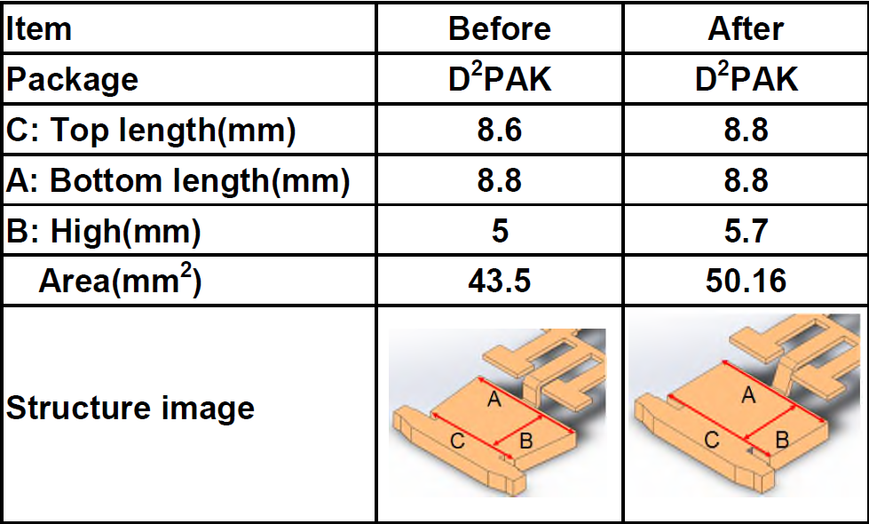

Reason for Change:
The purpose of the change is to enhance the heat dissipation capabilities of the D2PAK package.

Effect of Change:
This change does not affect the electrical characteristics of the product.

Qualification:
Standard evaluation and qualifications completed resulting in no performance
differences compared to current product.

Effective Date of Change:
Existing inventory will be shipped until depleted.

Sample Availability:

Please contact your salesperson or manufacturer’s representative for samples.

As per JEDEC standard JESD46, Customer Notification of Product/Process Changes by Solid-State Suppliers, a lack of acknowledgement of a PCN within thirty (30) days constitutes acceptance of the change.

The undersigned acknowledges and accepts Central Semiconductor’s Product/Process Change Notification (PCN).

Company Name:

Address:

Printed Name:

Title:

Signature:

Date:

