Process Change Notice

Parts Affected:
All Bridge Rectifiers in the SMDIP package.

Extent of Change:
Reduced thickness (height) of the epoxy body.

Reason for Change:
To provide a lower profile package.

Effect of Change:
No effect except for reduced height. No change in Mounting Pads required.

Effective Date of Change:
First quarter of 2002.

Sample Availability:
Please contact Salesperson or Manufacturer’s Representative.

Figures:

Figure 1. Present Package Figure 2. New Package

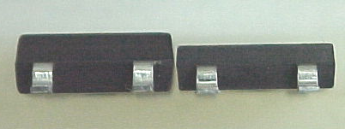

Figure 3. Comparison of Present and New Packages

Part Numbers Affected:

CBR1-D010S

CBR1-D020S
CBR1-D040S

CBR1-D060S
CBR1-D080S
CBR1-D100S
CBR1F-D020S
CBR1F-D040S
CBR1F-D060S
CBR1U-D010S
CBR1U-D020S

